**I) Ecommerce Website (GoShop):**

This E-commerce Website provides a user-friendly interface, enabling users to securely log in or register to access a wide range of products, including electronic gadgets, clothing items, and grocery products. The admin manages the addition of products to the platform, ensuring that the catalog remains up to date. Users can view detailed information about individual products and add selected items to their shopping cart, where the total cost of all selected products is automatically calculated. The website ensures checkout process, requiring users to fill in their billing details and complete their purchase. Additionally, users are encouraged to provide feedback on their experience, which is reviewed by the admin to identify areas for improvement and enhance the quality of services provided. For any queries, users can interact with a Query Clarification Chatbot, which provides instant assistance. Once the payment is successfully processed, the website generates a "Thank You" message, marking the completion of the user’s shopping experience.

Fig 1: ER Diagram for E-commerce Website

* Purpose: This ER diagram shows the database structure for storing user, product, and order information, facilitating data management by the admin.
* Technical aspect: This ER diagram helps in defining tables, relationships and primary keys, ensuring database normalization.

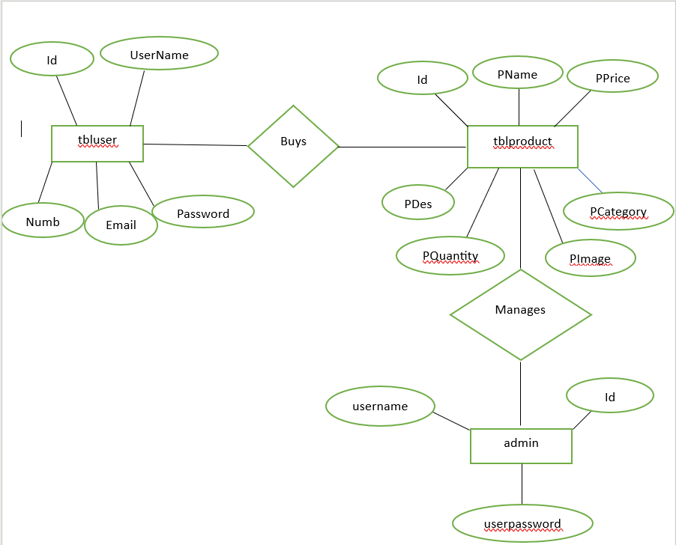

Fig 1: ER Diagram

Fig 2: E-Commerce Database Tables

* Purpose: Details table structures for managing users, products, orders, and feedback.
* Technical aspect: Each table includes primary keys, constraints, and data types. Foreign key relationships ensure data integrity.

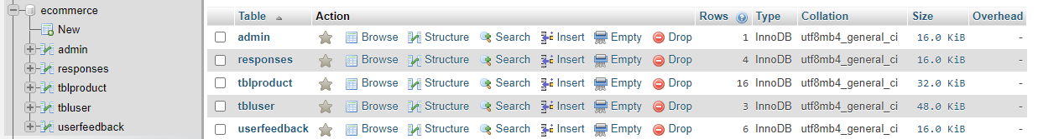

Fig 2: E-commerce database table

Fig 3: Admin Login Page Using PHP

* Purpose: Allows admins to securely log in, providing access to backend management features.
* Technical aspect: The PHP scripting language handles form submission and database connection, using SQL queries to verify credentials against a MySQL database. Configuration involved setting up session management in PHP to track admin login status.

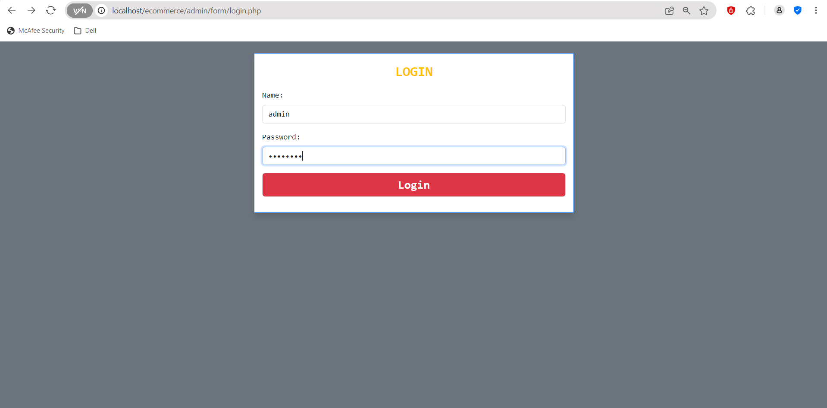

Fig 3: Admin login page

Fig 4: Prompt Message for Successful Login on Admin Side

* Purpose: Confirms successful login, providing user feedback.
* Technical aspect: JavaScript handles the prompt display, triggered by successful validation in PHP. The configuration includes ensuring session variables are set upon successful login.



Fig 4: Prompt Message for Successful Login on Admin Side

Fig 5: Displaying User Information for Admin for Verification

* Purpose: Displays registered users’ details, enabling admin verification.
* Technical aspect: PHP retrieves data from MySQL using SELECT queries, while HTML and CSS format the display. Pagination configuration was set for larger datasets, enhancing page load efficiency.

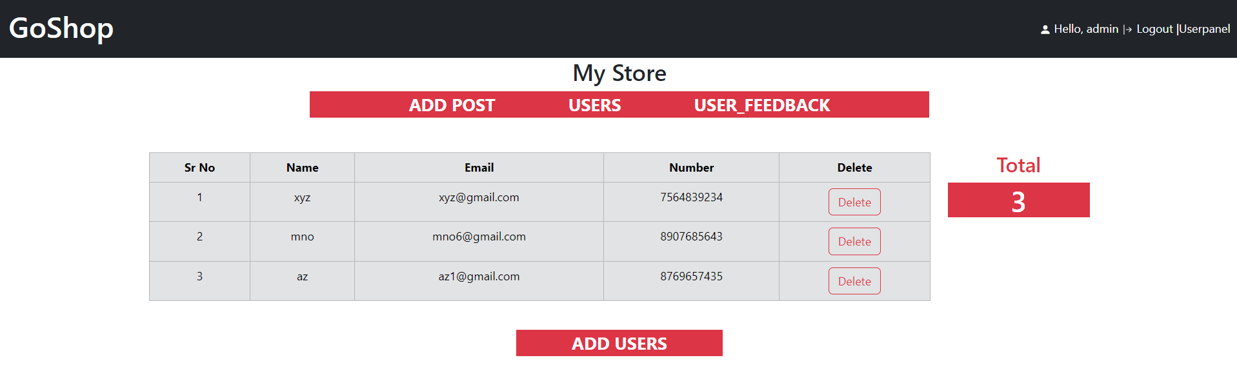

Fig 5: Displaying User Information for Admin for Verification

Fig 6: User Feedback Display and Delete Option for Admin

* Purpose: Allows admins to view and manage feedback.
* Technical aspect:PHP used for handling deletion requests. JavaScript provides a confirmation prompt for delete actions, and DELETE SQL statements remove records based on feedback ID.

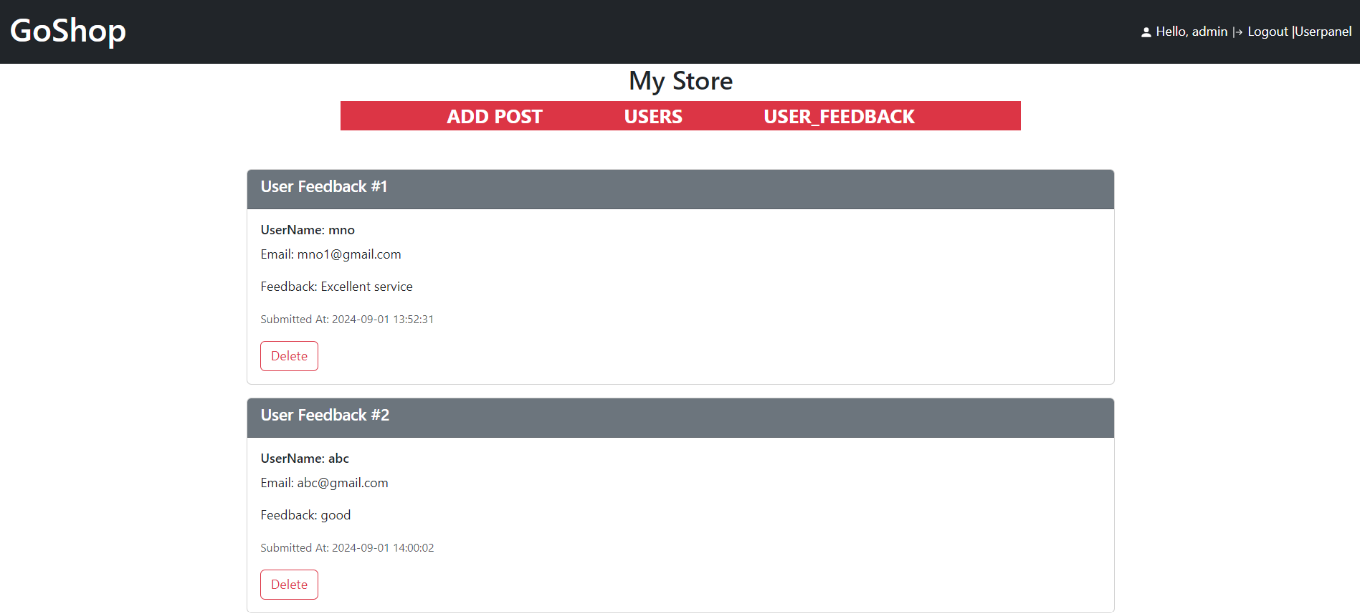

Fig 6: User Feedback Display and Delete Option for Admin

Fig 7: Product Details Entry Page for Admin

* Purpose: Enables product information input to populate the e-commerce catalog.
* Technical aspect: PHP and HTML form integration allow product data submission, while MySQL stores data. Image upload configuration includes defining maximum file size and allowed file types.

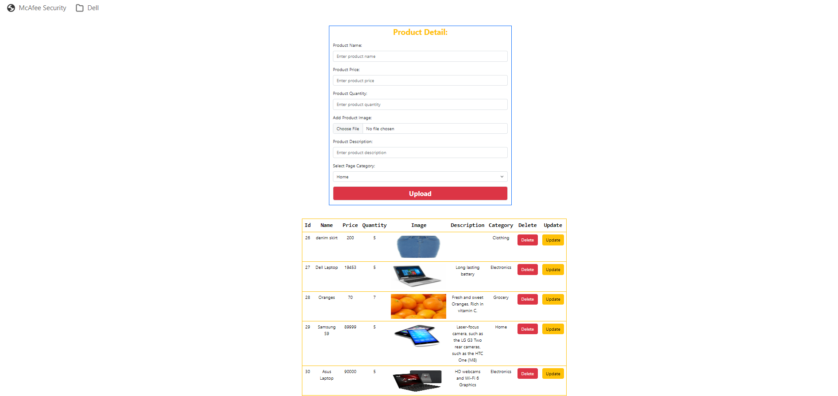

Fig 7: Product Details Entry Page for Admin

Fig 8: User Login and Registration Page

* Purpose: Allows users to register or log in for a personalized shopping experience.
* Technical aspect: PHP handles user registration, while form validation in JavaScript ensures proper input before submission. Configuration includes setting up error handling for duplicate registrations.



Fig 8: User Login and Registration Page

Fig 9: Successful Login Prompt for User

* Purpose: Confirms login and improves user experience.
* Technical aspect: JavaScript displays a notification, which is configured to disappear after a few seconds.



Fig 9: Successful Login Prompt for User

Fig 10: E-commerce Website Home Page

* Purpose: Serves as the main navigation page for users.
* Technical aspect: HTML and CSS create a user-friendly layout, while JavaScript manages navigation and dynamic content loading. Bootstrap was configured to ensure responsive design across devices.

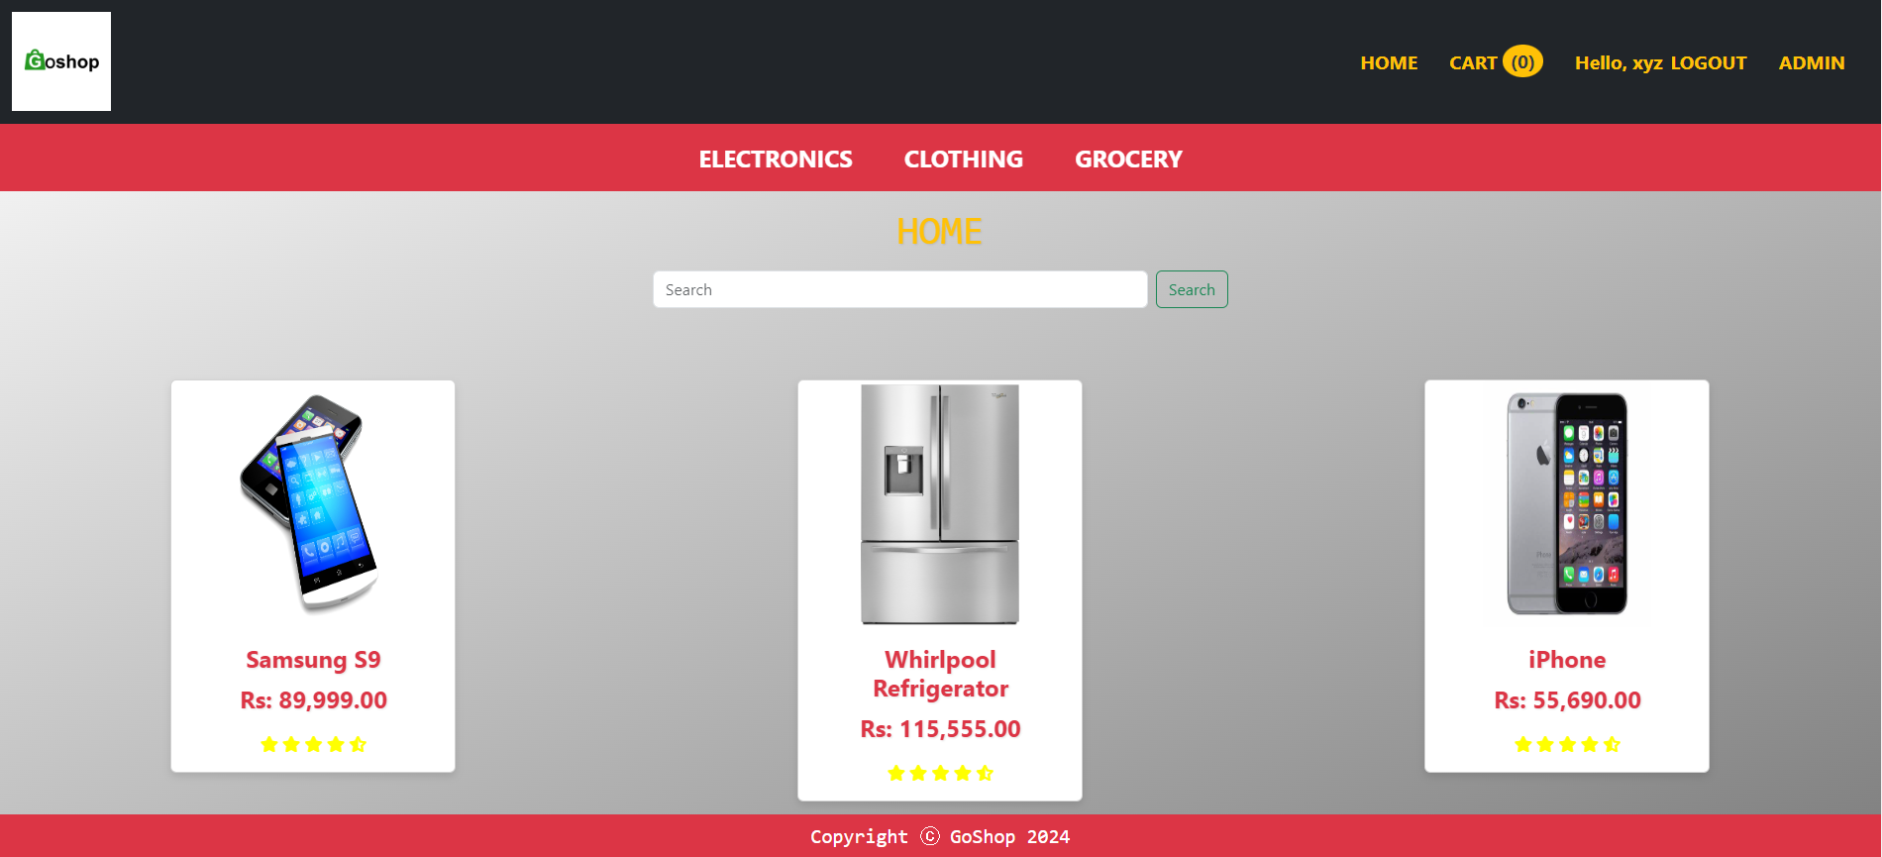

Fig 10: E-commerce Website Home Page

Fig 11: Query Clarification Chatbot for Users

* Purpose: Provides responses to common user queries.
* Technical aspect: PHP retrieves stored chatbot responses from a MySQL database.

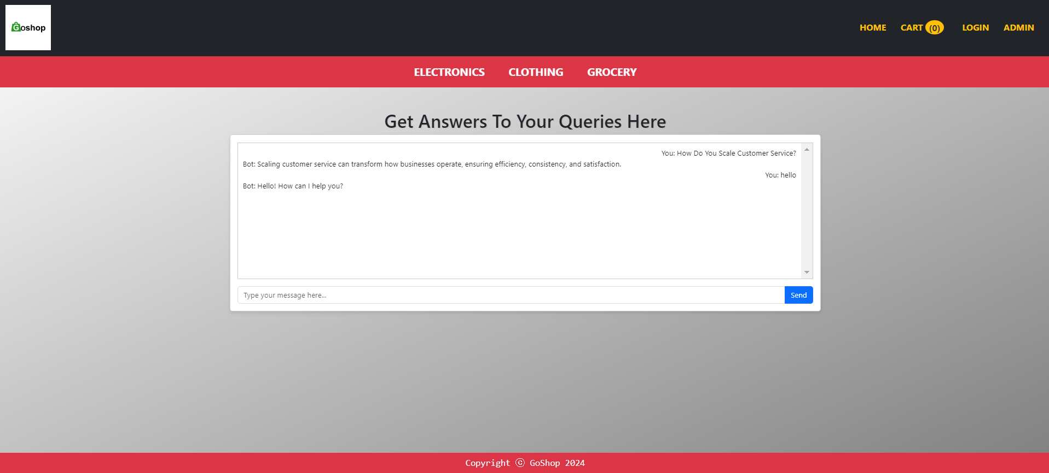

Fig 11: Query Clarification Chatbot for Users

Fig 12: Electronics Page

* Purpose: Displays electronic products, aiding product discovery.
* Technical aspect: PHP retrieves category-specific items from the database.

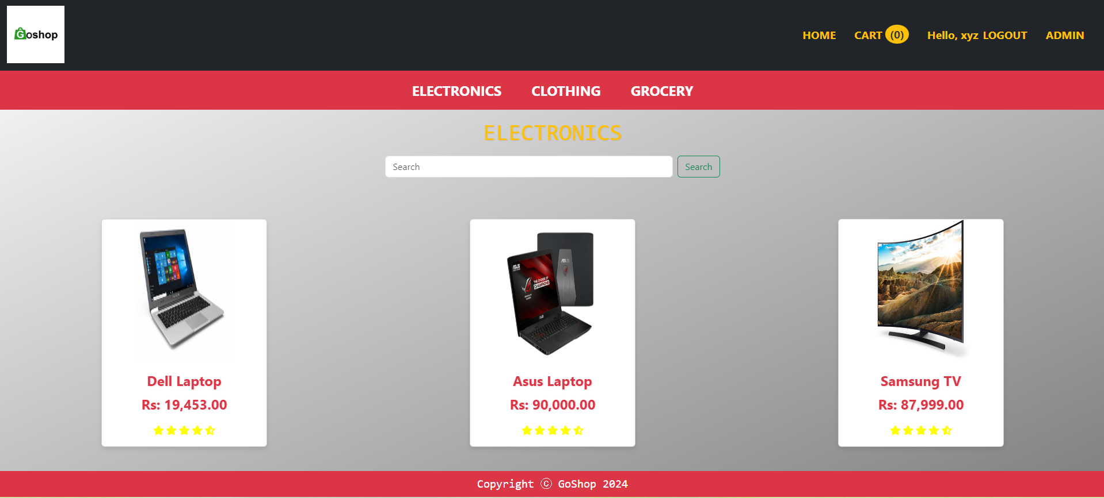

Fig 12: Electronics Page

Fig 13: Clothing Page

* Purpose: Organizes clothing items for easy browsing.
* Technical aspect:PHP used for dynamic loading and product sorting, enhance usability.

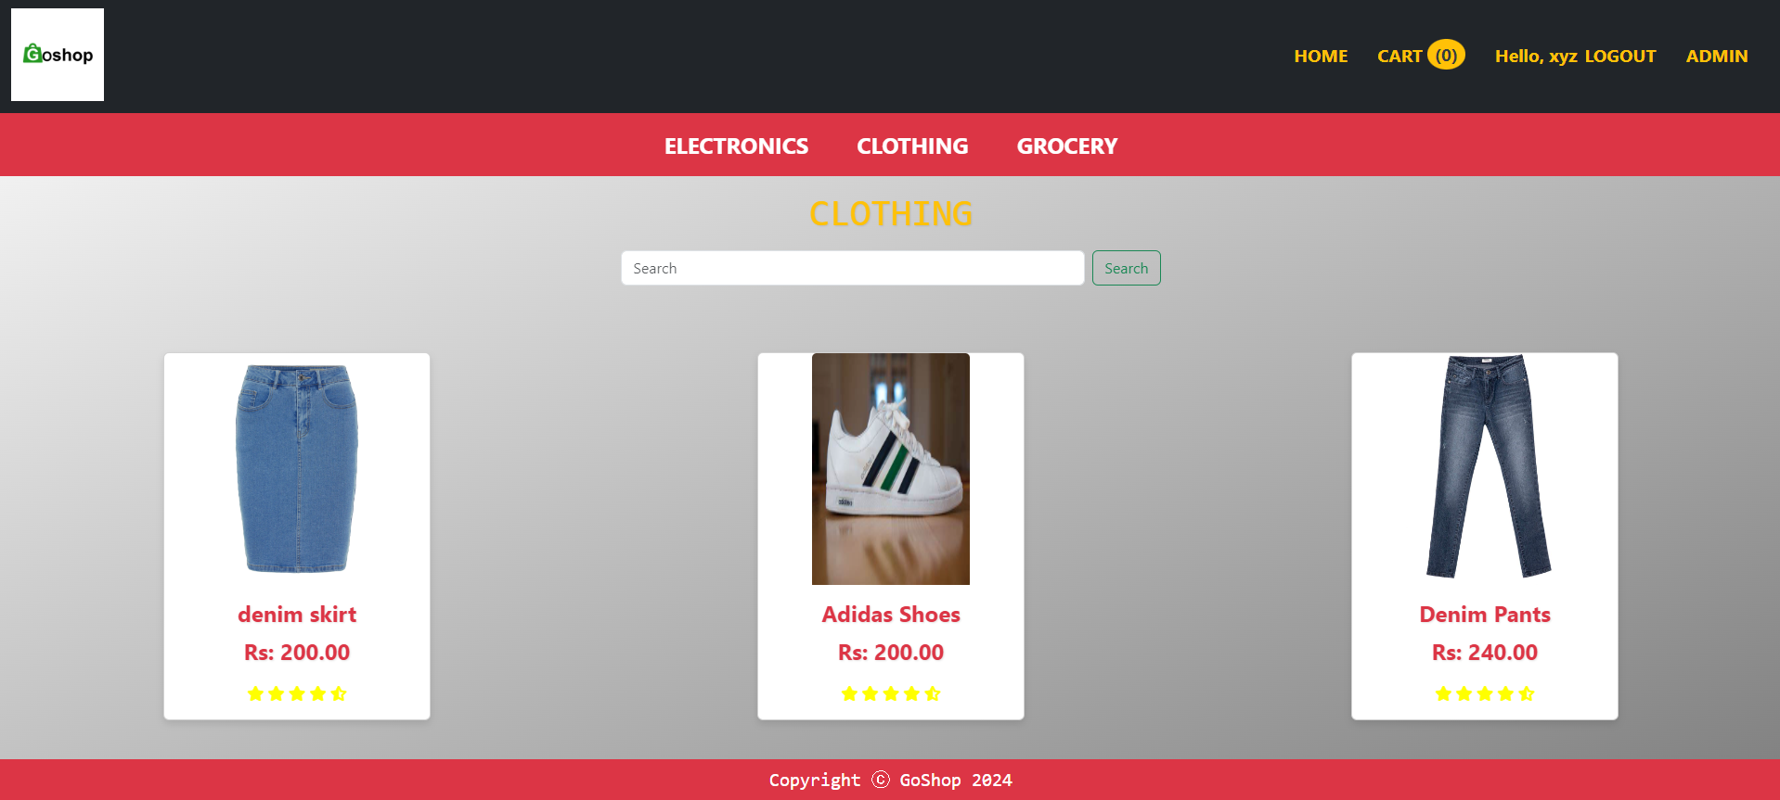

Fig 13: Clothing Page

Fig 14: Grocery Page

* Purpose: Provides an organized display of grocery items.
* Technical aspect: Similar to the Electronics page, PHP entirely used for designing the site.

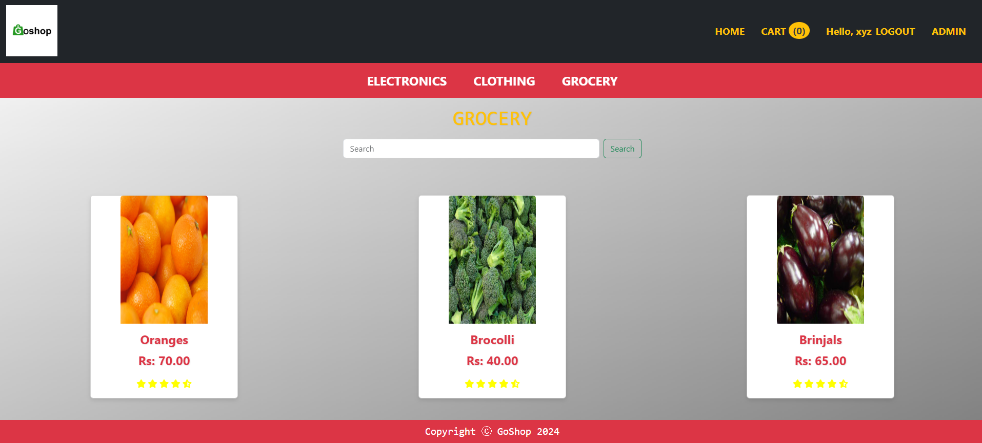

Fig 14: Grocery Page

Fig 15: Individual Product Display Page

* Purpose: Displays detailed information about a selected product.
* Technical aspect: PHP retrieves product data, with bootstrap handling image previews.

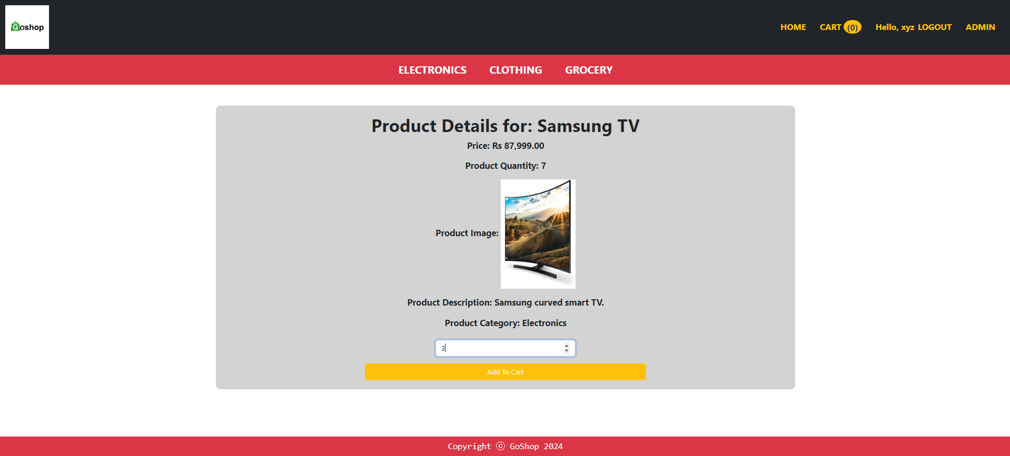

Fig 15: Individual Product Display Page

Fig 16: Add to Cart Feature

* Purpose: Allows users to select items for purchase.
* Technical aspect: PHP used to store cart data in sessions.

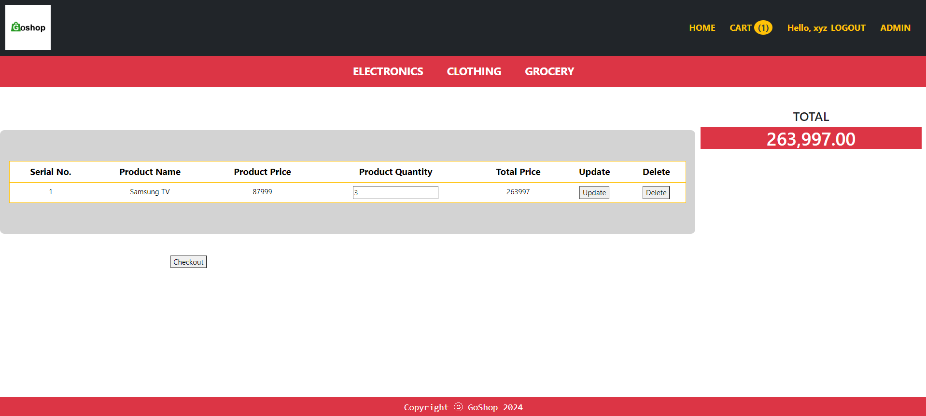

Fig 16: Add to Cart Feature

Fig 17: Checkout and Billing

* Purpose: Displays order details for final purchase.
* Technical aspect: PHP used to calculate total and styling through bootstrap and font-awsome.

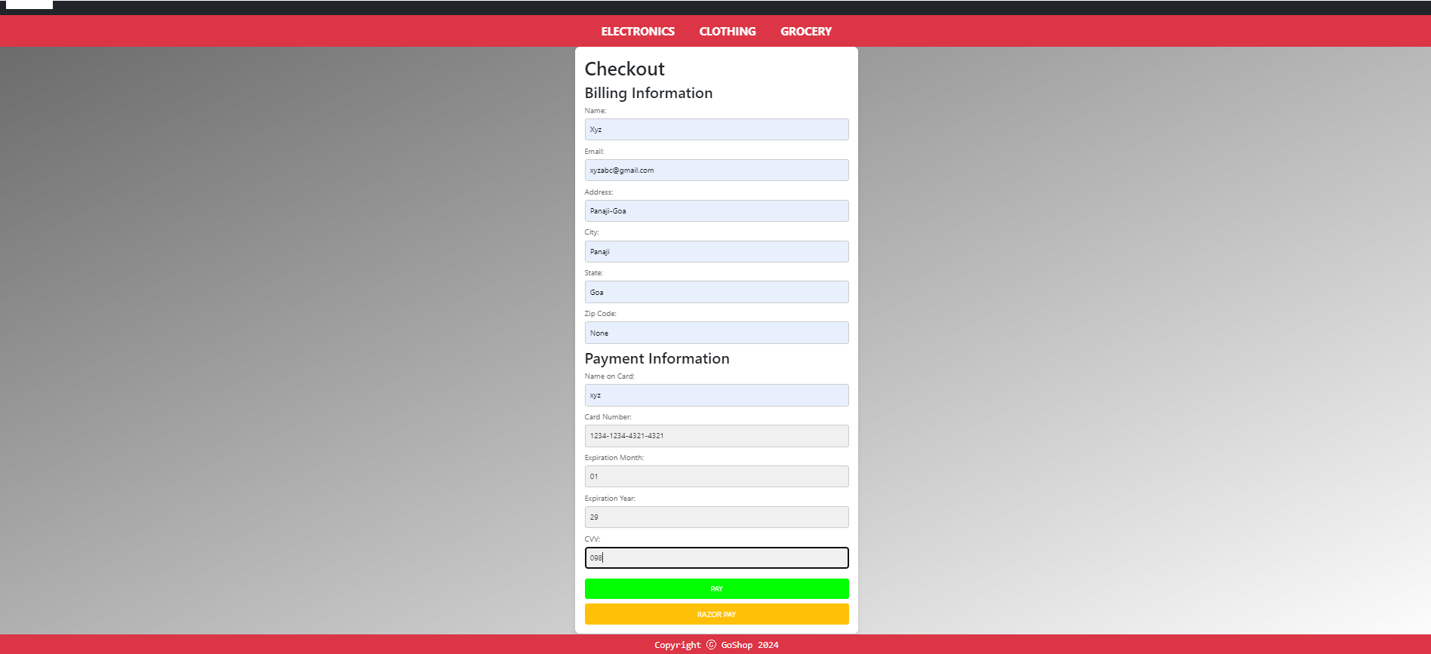

Fig 17: Checkout and Billing

Fig 18: User Feedback Page

* Purpose: Collects feedback to improve service quality.
* Technical aspect: PHP processes and stores feedback

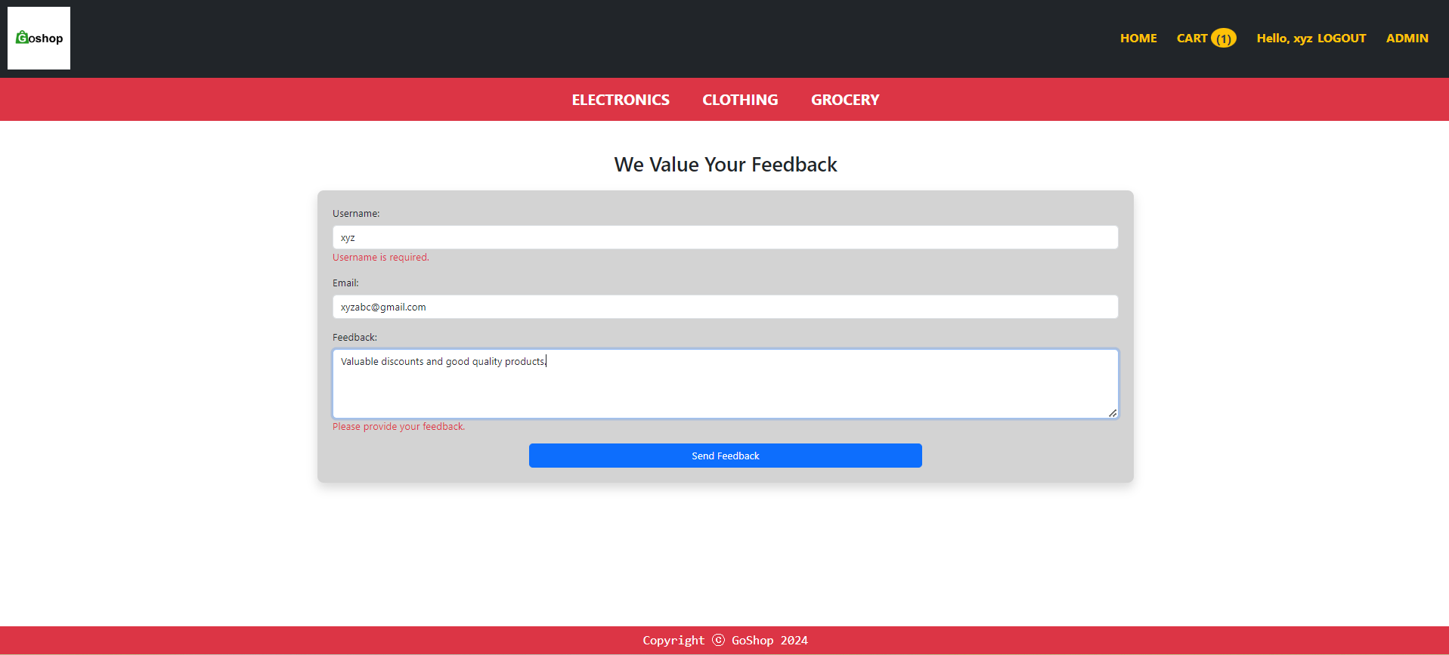

Fig 18: User Feedback Page

Fig 19: Thank You Page

* Purpose: Provides post-purchase confirmation.
* Technical aspect: Thank-you message, with order details displayed using session data.



Fig 19: Thank You Page